“The Best of Two Worlds” – introductory article by Dieter Wilhelmy for the series: Moin-Moin from America, in the prominent monthly magazine section of the FLENSBURG JOURNAL, 31 May 2013
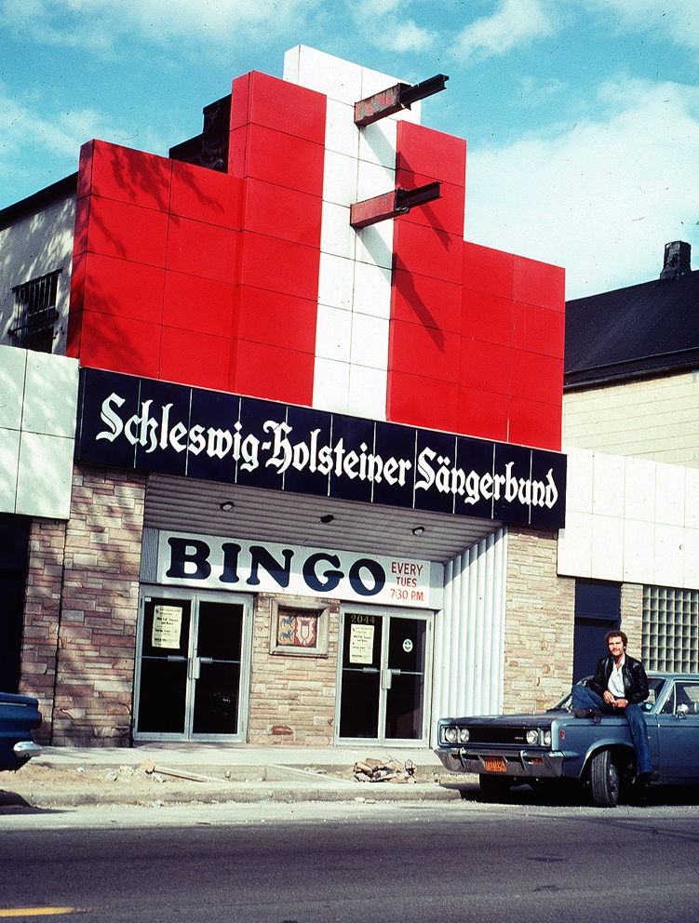
Caption 1: Chicago 1978. Visiting the Schleswig-Holstein Choir from 1883.

Dr. Joachim “Yogi” Reppmann is a historian who, beginning in 1992, has been spending six months per year in Northfield, Minnesota with his wife Gitta and the other six months in Flensburg.

We met for the first time in April in their spacious apartment, part of a villa in the Western Heights. All their suitcases had not yet been unpacked, the traces of their six months’ absence were still evident, and Joachim and Gitta had not completely overcome their jet lag.

It did not take us long to begin calling each other by our first names, and that provided us with a topic of conversation: the openness of Americans, in the sense of “My house is your house”—something that is often seen as superficial from the perspective of old Europe.

For us Europeans it can seem disconcerting or even an indication of disdain. We feel that the sudden use of first names places us on a level of intimacy with those we might deem socially inferior: a construction worker in the street, a pizza delivery boy, a handyman who has come to fix the toilet. Customarily it takes months or even years until an older person suggests such a level of intimacy to a younger one, or the boss to a subordinate co-worker, or simply one colleague to another. This takes place while maintaining certain medieval rites: a handshake, an embrace, or the interlocking of arms, accompanied by the imbibing of a high-proof beverage. Even contemporary advertising has picked up on this ritual, as in “When Herr Weber finally becomes Sebastian” (Bitburger Pilsner).

So just how serious is it for an American when he receives a “stranger” with open arms?

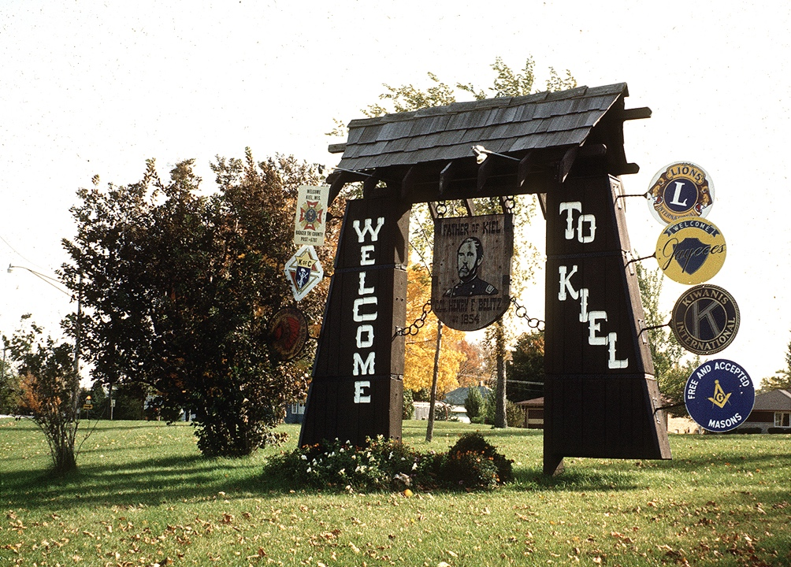
Caption 2: Kiel, Wisconsin, North of Chicago, Welcomes it's visitors

Yogi Reppmann explains that it is based on “a different way of thinking in comparison to ours. Our starting position is that an unknown person might be a danger for us, we basically don’t trust that person. The American view is the opposite: every stranger could ultimately become my friend. And so I don’t create a barrier by behaving in a distanced, mistrustful way. I will ultimately find out to what degree I can trust that person and whether our relationship will last.” We consider contacts that do not end up as friendships, or fizzle out, or are not fostered, to be superficial.

Yogi Reppmann, however, can cite many examples of his early experiences in America in which the open manner shown by Americans simplified his introduction to his new culture.

His enthusiasm for the “States” began as far back as childhood. Karl May’s fantasy novels about the Wild West provided the first impulse. The writer from Saxony did not experience America personally until after his novels had achieved market success. Reppmann’s idealized image of America did not even suffer during his school and university years, when most in his age group fought against the ugly face of America and shouted “Ami go home” at demonstrations against the war in Vietnam. What counted more in the development of his image of America than the Washington imperialism that others alleged were extraordinary actions such as the Berlin Air Bridge of 1948-49. His dream became reality when, following his graduation from school in 1976, he and a pal shouldered their backpacks and used their hard-earned money to book a flight to New York.

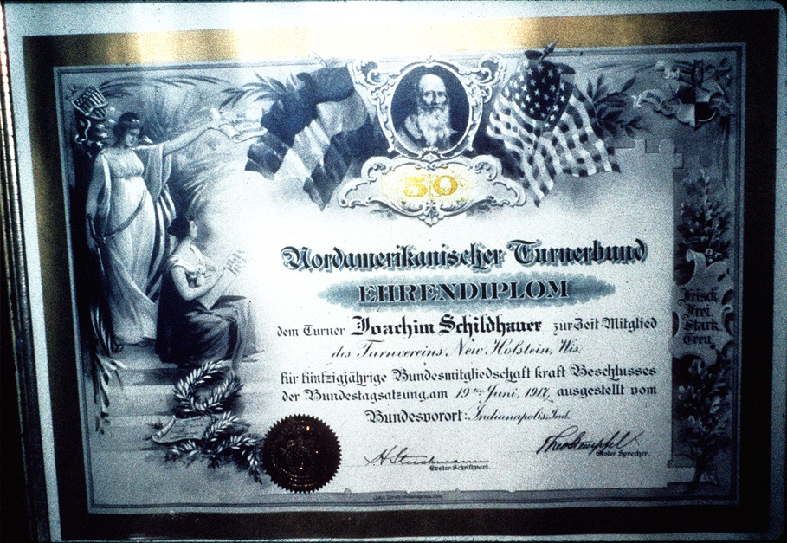
Caption 3: New Holstein, Wisconsin, next to Kiel, WI, Yogi Reppmann enjoyed the Pioneer Corner Museum (www.newholsteinhistory.info)

Aside from one exchange student with the everyday name of Roger Smith, Yogi Reppmann had never met any Americans. And aside from a slip of paper containing the address of the boy, plus the adventurous plan of hitchhiking through as many states in America as possible, the two Flensburgers found themselves in the metropolis with no other source of help. But in typical American fashion they were welcomed with open arms by Roger’s parents who were their hosts for a week. Then began the tour they had been dreaming of, through the south of Canada, the northwest of the United States, and then south to San Francisco and the warmth of New Orleans and Florida. They hitchhiked, slept in fields near the highway, spent a night in a motel in Las Vegas, and were warmly taken in hand by complete strangers and treated “amazingly well.” Seen from Yogi Reppmann’s perspective today, this set the course for the remainder of his life.

More than anything, Yogi was delighted by most Americans’ fundamentally positive attitude toward life, their curiosity, their extreme politeness and their willingness to help.

When he established a home in the United States many years later, experiences like these continued. He had scarcely moved into a house with his life’s partner and later wife Gitta when neighbors were standing at their front door—the women with cake and cookies, the men with their tools—to greet them and ask how they could help.

By that time Yogi Reppmann had become a scholar of history and a professor in the northern state of Minnesota, where he did research, taught at liberal arts colleges, and established connections between the United States and Germany.

One person who particularly impressed him and became a friend was Gerhard “Stolti” Stoltenberg, Prime Minister of the state of Schleswig-Holstein from 1971 to 1982 and later Minister of Finance and Defense in Bonn. Stoltenberg helped fund a research stay for the young historian in the American Midwest. Yogi Reppmann and his fellow scholars were in search of Schleswig-Holstein place names in the United States and how they had come to be established. They made several finds in their search and ultimately were able to express their thanks to their benefactor in the city of Kiel, Wisconsin.

The history of German emigration, especially following the failed democratic revolution of 1848, became the life’s work of this Flensburg historian. It was not only the historic events at the Church of St. Paul in Frankfurt, but also Schleswig-Holstein and its democratic-minded citizens Theodor and Justus Olshausen, who contributed to the idea of the creation of a German state with a liberal constitution. The ultimate failure of this attempt and the resulting forced exile of many influential intellectuals, was of decisive influence on the development of America. The “Forty-Eighters” are a firmly-rooted concept in the history of that country. A weekend seminar at the Akademie Sankelmark, co-initiated by Yogi Reppmann and attended by well-known scholars from Germany and the United States, offers excellent insights into Schleswig-Holstein-American history.

Caption 4: New Holstein, WI, had been founded 1848 by Democratic revolutionaries from the German state of Schleswig-Holstein, north of Hamburg. "Altona" today is a restaurant in New Holstein had been in the German Dutchy of Holstein the largest city.

